1. s

A Project Report On

**ONLINE PET ADOPTION**

**<Projepnjvfjt Title>**

Submitted in partial fulfillment of the requirement for the award of the degree

Bachelor of Computer Application (BCA)

Academic Year 2025 – 26

**MAITRI SAGAPARIYA TULSI JOSHI**

**92300527059 92300527060**

|  |
| --- |
| **Internal Guide** |
| Jignesh Hirapara |



Rajkot-Morbi Road, At & PO : Gauridad, Rajkot 360 003. Gujarat. India.



**Faculty of Computer Applications (FCA)**



**This is to certify that the project work entitled**

**ONLINE PET ADOPTION**

**submitted in partial fulfillment of the requirement for**

**the award of the degree of**

**Bachelor of Computer Application**

**of the**

**Marwadi University**

**is a result of the bonafide work carried out by**

**MAITRI SAGAPARIIYA(92300527059)**

**TULSI JOSHI(92300527060)**

**during the academic year 2025-26**

Vinod Kumar Pal Sunil Bajeja Sridaran Rajagopal

|  |  |  |  |  |
| --- | --- | --- | --- | --- |
| **Faculty Guide** |  | **HOD** |  | **Dean** |

**DECLARATION**

I/Wehereby declare that this project work entitled **ONLINE PET ADOPTION** is a record done by me.

I also declare that the matter embodied in this project is genuine work done by me and has not been submitted whether to this University or to any other University / Institute for the fulfillment of the requirement of any course of study.



Place : MARWADI UNIVERSITY

Date : 28/08/2025

**MAITRI SAGAPARIYA(92300527059) Signature :**



**TULSI JOSHI(92300527060) Signature :**



**ACKNOWLEDGEMENT**

It is indeed a great pleasure to express our thanks and gratitude to all those who helped us. No serious and lasting achievement or success one can ever achieve without the help of friendly guidance and co-operation of so many people involved in the work.

We are very thankful to our guide **JIGNESH HIRAPARA,** the person who makes us to follow the right steps during our project work. We express our deep sense of gratitude to for his /her guidance, suggestions and expertise at every stage. A part from that his/her valuable and expertise suggestion during documentation of our report indeed help us a lot.

Thanks to our friend and colleague who have been a source of inspiration and motivation that helped to us during our project work.

We are heartily thankful to the Dean of our department **Dr. R. Sridaran** sir and HoD **Dr. Sunil Bajeja** sir for giving us an opportunity to work over this project and for their end-less and great support to all other people who directly or indirectly supported and help us to fulfil our task.

**CONTENTS**

|  |  |  |
| --- | --- | --- |
| **Chapters** | **Particulars** | **Page No.** |
| **1** | **SYNOPSIS** | 7 |
| **2**  2.1  2.2 | **PREAMBLE**  General Introduction  Module description | 8 |
| **3** | **REVIEW OF LITERATURE** | 10 |
| **4** | **TECHNICAL DESCRIPTION**  Hardware Requirement  Software Requirement | 11 |
| **5** | **SYSTEM DESIGN AND DEVELOPMENT**  **(Only applicable diagrams)**  **Architectural Design**   * Class Diagram   **Dynamic Modeling**   * Use Case Diagram * Sequence Diagram * Activity Diagram   Database Design (If applicable)  Relationship Diagram (ER)  Menu Design  Screen Design | 13 |
| **6** | **CONCLUSION** | 20 |
| **7** | **LEARNING DURING PROJECT WORK** | 20 |
| **8**  **8.1**  **8.2** | **REFFERENCE**  Online References  Offline References | 22 |

**TABLE INDEX**

|  |  |  |
| --- | --- | --- |
| **Table No.** | **Title** | **Page No.** |
| 4.1 | Hardware Requirement | 11 |
| 4.2 | Software Requirement | 12 |

**Figure Index**

|  |  |  |
| --- | --- | --- |
| **Table No.** | **Title** | **Page No.** |
| **5.1** | **Architectural Design** | 13 |
| **5.2** | **Dynamic Modeling** | 14 |
| **5.2.1** | **Use Case Diagram** | 14 |
| **5.2.2** | **Sequence Diagram** | 14 |
| **5.2.3** | **Activity Diagram** | 15 |
| **5.3** | **ER Diagram** | 15 |
| **5.4** | **Menu Design** | 16 |
| **5.5** | **Screen Design** | 16 |
| **5.5.1** | **Index Page** | 16 |
| **5.5.2** | **Pet Page** | 17 |
| **5.5.3** | **Login Page** | 18 |
| **5.5.4** | **Register Page** | 19 |
| **5.5.5** | **Admin Page** | 19 |

### 1.SYNOPSIS

### Project Overview :-

The **Pet Adoption System** is a web-based application designed to help users adopt pets online. It provides separate functionalities for **administrators** and **users**, allowing management of pet listings, user registrations, and adoption tracking.

### Key Features :-

1. **User Features:-**
   * Register and log in to the system.
   * Browse available pets (cats, dogs, etc.) with images.
   * View detailed pet information.
   * Adopt pets through the platform.
   * Personal **user dashboard** to track adoptions.
2. **Admin Features:-**
   * Admin login system.
   * Add, update, and delete pet listings (with images).
   * Manage users and adoption requests.
   * Monitor adoption records and available pets.
3. **System Functionality:-**
   * **Authentication**: Login/Logout for both users and admin.
   * **Pet Management**: Upload images, details, and breeds of pets.
   * **Database Integration**: Uses MySQL (via db.php) to store user and pet information.
   * **Responsive UI**: Built with style.css and app.js.

### Project Structure :-

* **PHP Backend:-**
  + index.php → Homepage
  + register.php, login.php, logout.php → User authentication
  + user_dashboard.php → User panel
  + admin.php → Admin dashboard
  + pet.php → View/manage pet details
  + delete_pet.php → Remove pet listings
  + db.php → Database connection
* **Frontend:-**
  + style.css → Styling
  + app.js → Client-side interactivity
* **Uploads**
  + Contains images of pets available for adoption.

## ****2.Preamble****

In today’s digital era, technology has become a powerful medium for solving real-world problems efficiently. With increasing numbers of stray and abandoned animals, pet adoption platforms have gained importance as they connect people willing to adopt pets with shelters or individuals looking to rehome them. Traditional adoption methods are time-consuming and geographically limited. To address this gap, an online **Pet Adoption Management System** is proposed, which simplifies the process by providing a centralized platform for managing adoption activities.

## ****2.1 General Introduction****

The **Pet Adoption System** is a web-based application that allows users to view, select, and adopt pets conveniently through an online platform. It eliminates the need for physical visits to multiple shelters by showcasing a catalog of available pets with their details and images.

The system has two main roles:

* **Users (Adopters):** Can register, log in, browse pets, and request adoption.
* **Administrators:** Can manage pet listings, update availability, and maintain user adoption records.

The system integrates PHP for server-side logic, MySQL for database management, and CSS/JavaScript for frontend interaction, providing a complete and user-friendly experience.

## ****2.2 Module Description****

### 1. ****User Module:-****

* User registration and login.
* Profile management.
* Browse/search available pets by category, breed, or other filters.
* View detailed pet information with images.
* Request adoption and track adoption status through the user dashboard.

### 2. ****Admin Module****

* Secure admin login.
* Add new pets with details (name, breed, age, description, image).
* Update pet information (availability, description).
* Delete pet records from the system.
* Manage registered users and adoption requests.

### 3. ****Pet Management Module****

* Handles storage and retrieval of pet details.
* Manages uploaded images for each pet.
* Ensures real-time update of availability when pets are adopted.

### 4. ****Authentication & Security Module****

* Manages login, logout, and session handling.
* Prevents unauthorized access to admin functionalities.
* Secures user data via proper validation and storage in the database.

### 5. ****Database Module****

* Maintains structured records of users, pets, and adoption history.
* Supports CRUD (Create, Read, Update, Delete) operations.
* Ensures data consistency across the platform.

# ****3.Review of Literature****

The increasing need for efficient management of animal adoption processes has led to the development of several systems and studies in this domain. A review of existing literature and related works reveals the following:

### 1. ****Traditional Adoption Systems****

Conventional pet adoption has long been handled through animal shelters, rescue organizations, or direct rehoming by owners. While effective, these methods are often **time-consuming, geographically restricted, and lack transparency**. Prospective adopters usually need to make multiple visits to shelters, which may not guarantee success. This limitation has highlighted the need for digitized solutions.

### 2. ****Web-based Pet Adoption Platforms****

Several organizations have introduced online platforms to streamline adoption processes.

* **Petfinder (2003):** One of the earliest online adoption platforms, it provided a centralized database of adoptable pets across multiple shelters. However, it primarily focused on listing pets and did not fully address **user–admin interaction and adoption tracking**.
* **Adopt-a-Pet:** A widely used service offering pet search features and shelter integrations, but it functions as a **third-party listing service** rather than a customizable adoption management system for local organizations.

These systems have inspired the development of smaller, customizable portals that individual shelters or communities can adopt.

### 3. ****Academic and Research Works****

* Various academic projects in **Computer Science and Information Technology** have explored the idea of online adoption portals. These projects usually implement **basic CRUD operations, authentication, and image uploads** for pets.
* Some studies emphasize the importance of **user experience** in adoption platforms, suggesting that intuitive navigation and visual pet catalogs significantly increase adoption rates.
* Recent research also suggests integrating **AI-based recommendations** (matching adopters with suitable pets) and **mobile apps** to enhance adoption engagement.

### 4. ****Gaps in Existing Systems****

While existing commercial platforms are robust, they are often **centralized, large-scale, and difficult to customize** for smaller shelters. Many academic prototypes, on the other hand, lack **completeness** (e.g., absence of admin dashboards, weak security, or poor UI).

# ****4.Technical Description****

## ****4.1 Hardware Requirements****

|  |  |
| --- | --- |
| **Component** | **Minimum Requirement** |
| Processor | Intel Core i3 (or equivalent AMD) |
| RAM | 4 GB |
| Hard Disk | 500 MB free space for project files and database |
| Display | 1024 × 768 resolution |
| Network | Basic LAN/Wi-Fi connection for database & web server interaction |

## ****4.2 Software Requirements****

|  |  |
| --- | --- |
| **Category** | **Specification** |
| Operating System | Windows 10 / 11 (recommended) Linux (Ubuntu / Fedora) macOS (alternative) |
| Backend Technologies | Server: XAMPP / WAMP / LAMP (Apache server) Database: MySQL Server-side Scripting: PHP (v7.x or higher) |
| Frontend Technologies | HTML5, CSS3 , JavaScript (with optional frameworks/libraries) |
| Tools & IDEs | Code Editor: Visual Studio Code / Sublime Text / Notepad++ Browser: Google Chrome / Mozilla Firefox / Edge phpMyAdmin for managing MySQL database |
| Additional Requirements | Web server stack installed (XAMPP recommended for local development) Image upload support for pet profiles Compatible with all major modern browsers |

**5.System Design and Development:-**

**Figure 5.1 Architectural Design**

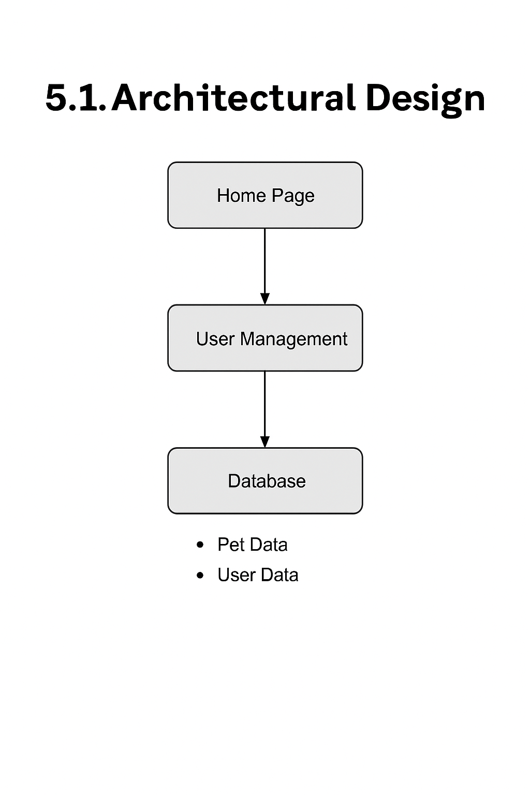

**5.2 Dynamic Modeling:-**

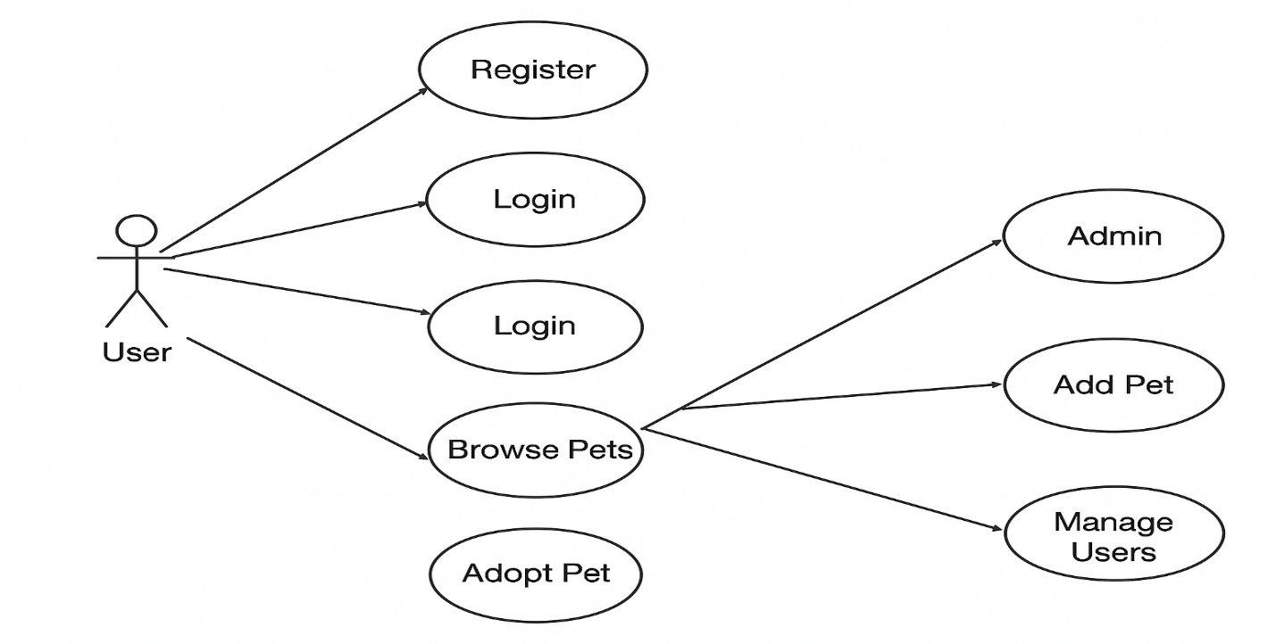

**Figure 5.2.1 Use Case Diagram**

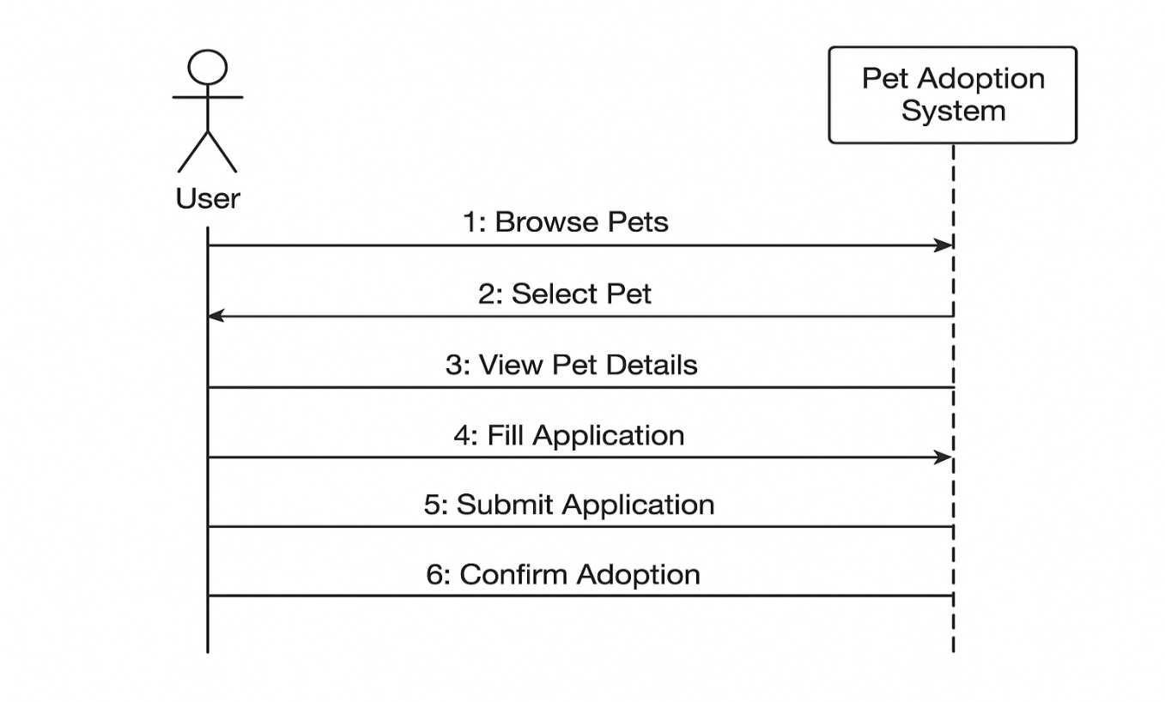

**Figure 5.2.2 Sequence Diagram**

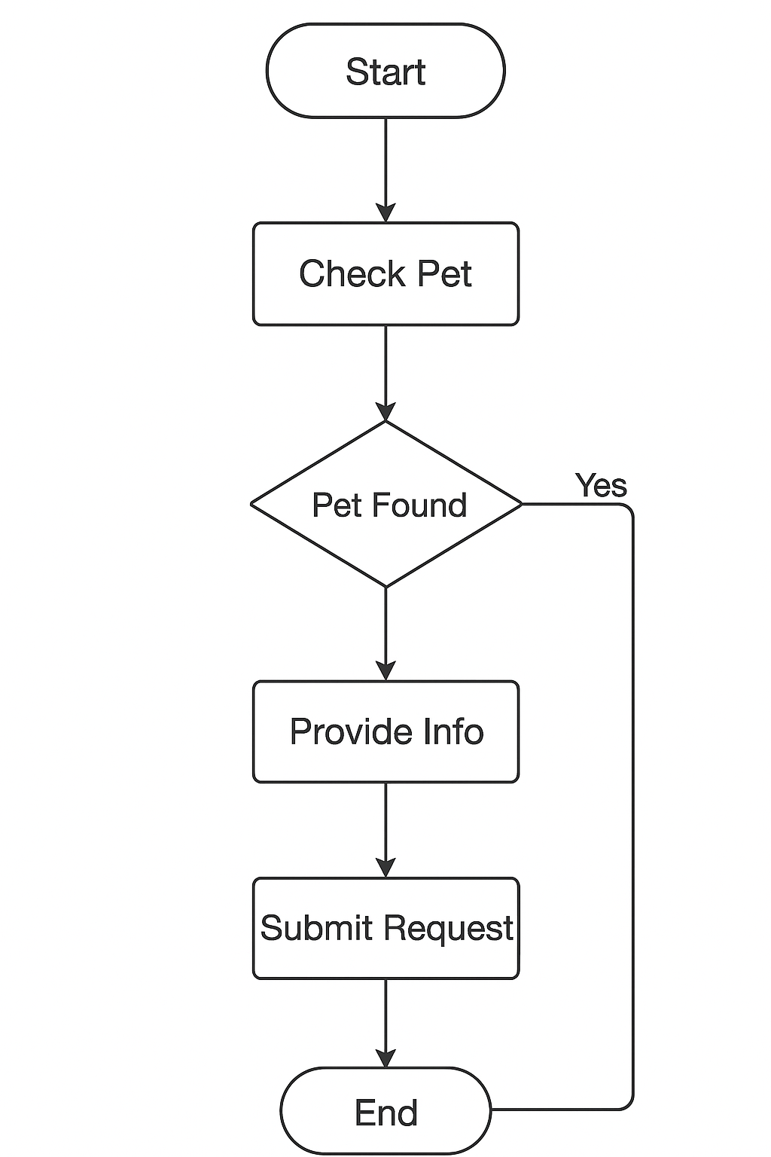

**Figure 5.2.3 Activity Diagram**

### ****5.3 ER Diagram:-****

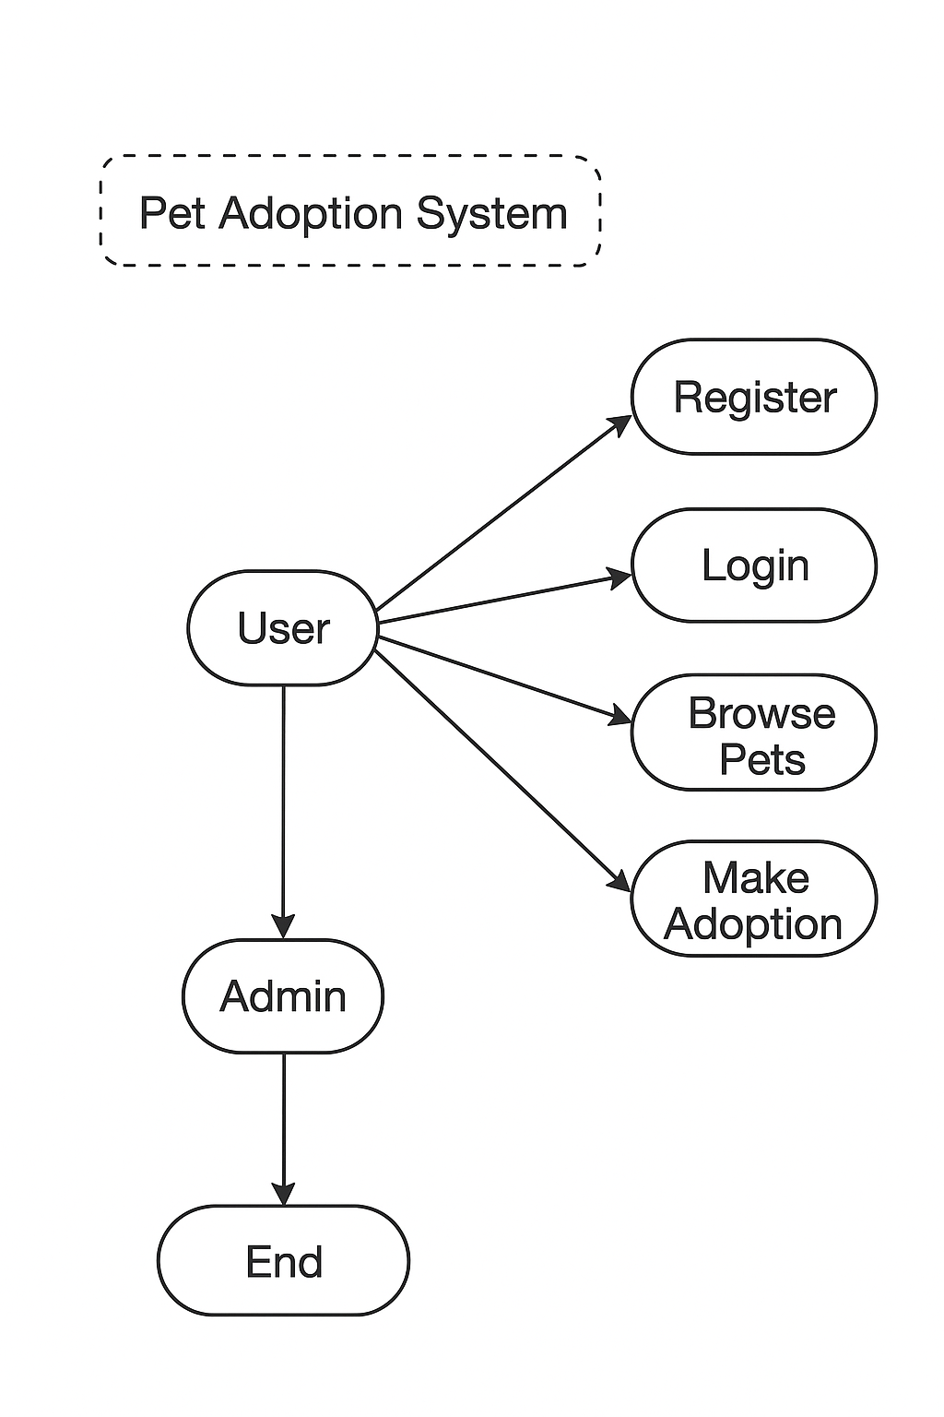

## ****5.4 Menu Design:-****

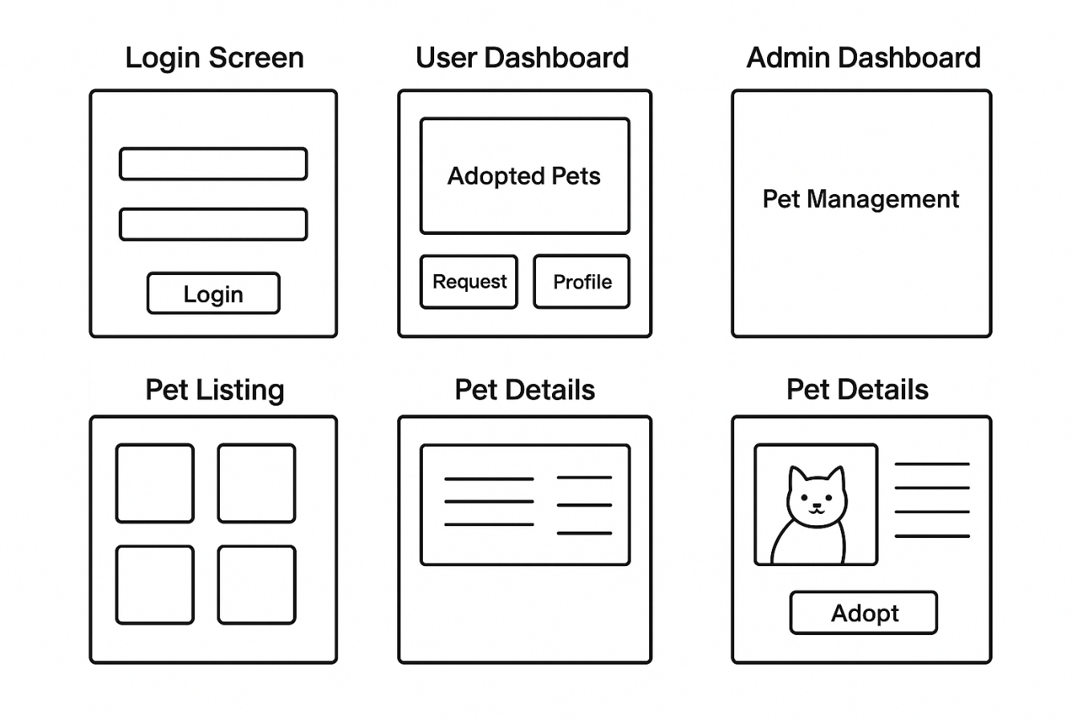

**5.5 Screen Design:-**

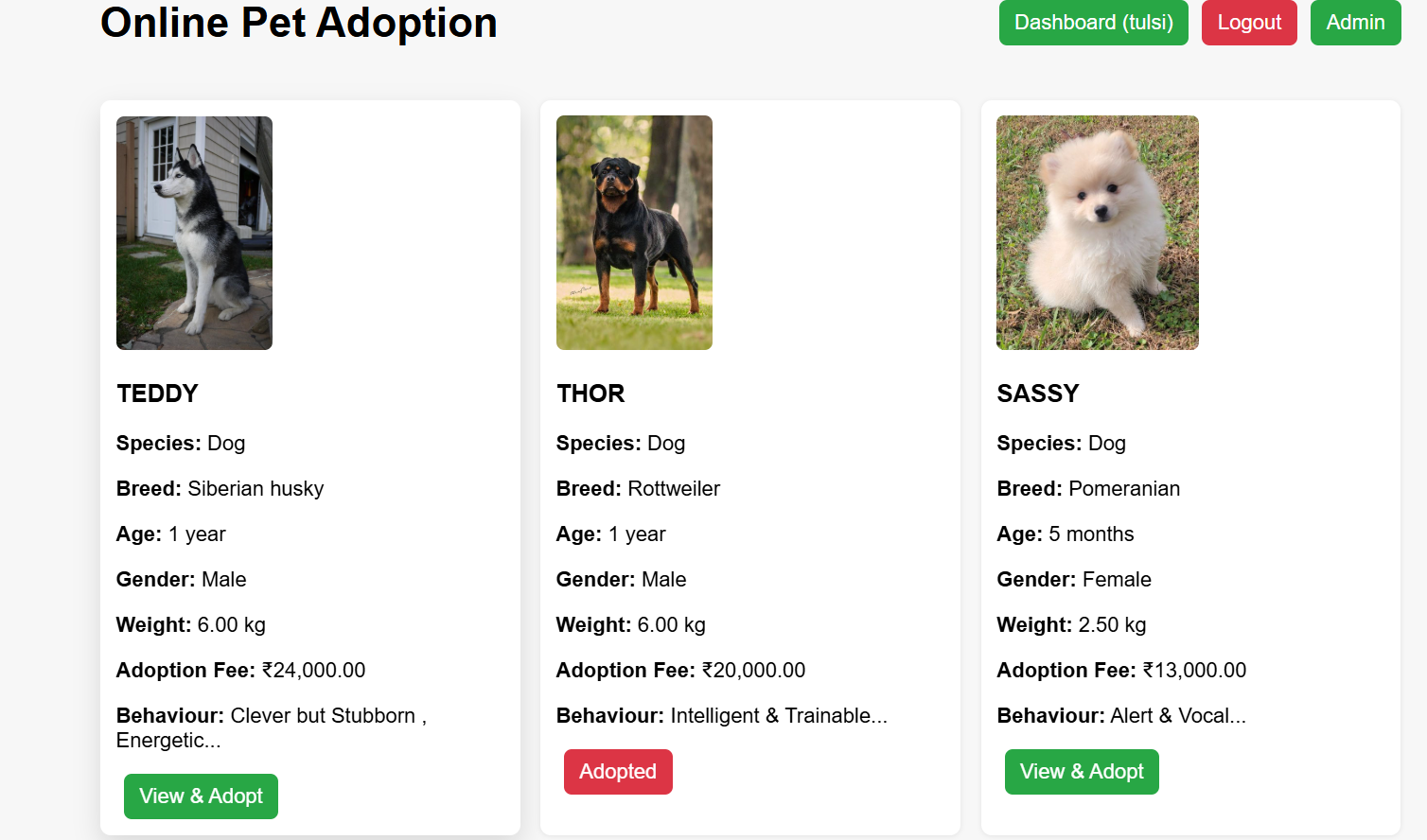

**Figure 5.5.1 Index page**

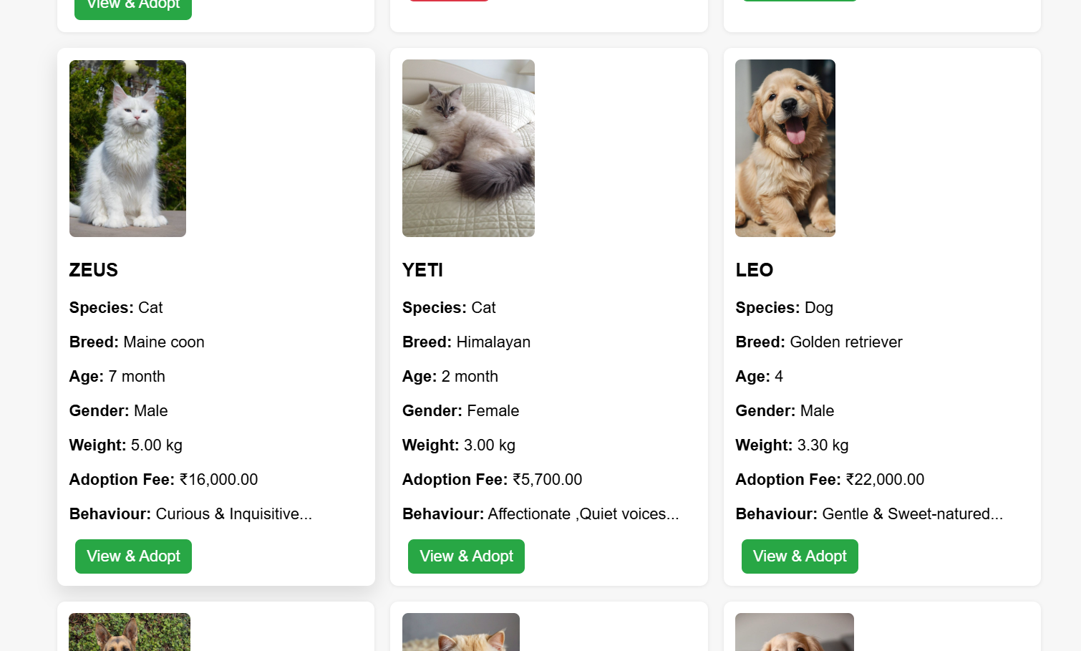

**Figure 5.5.1 Index page**

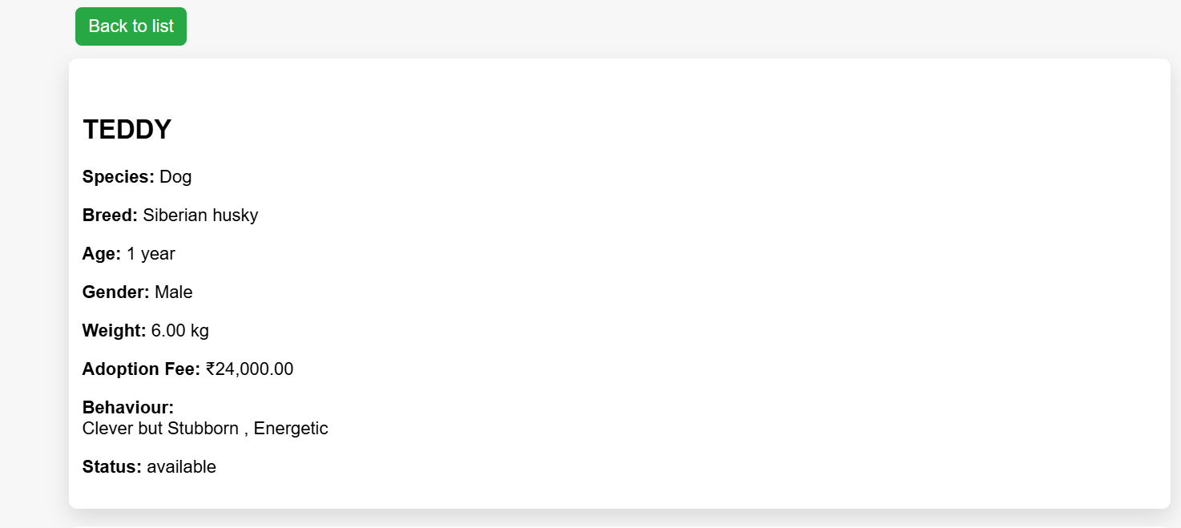

**Figure 5.5.2 Pet Page**

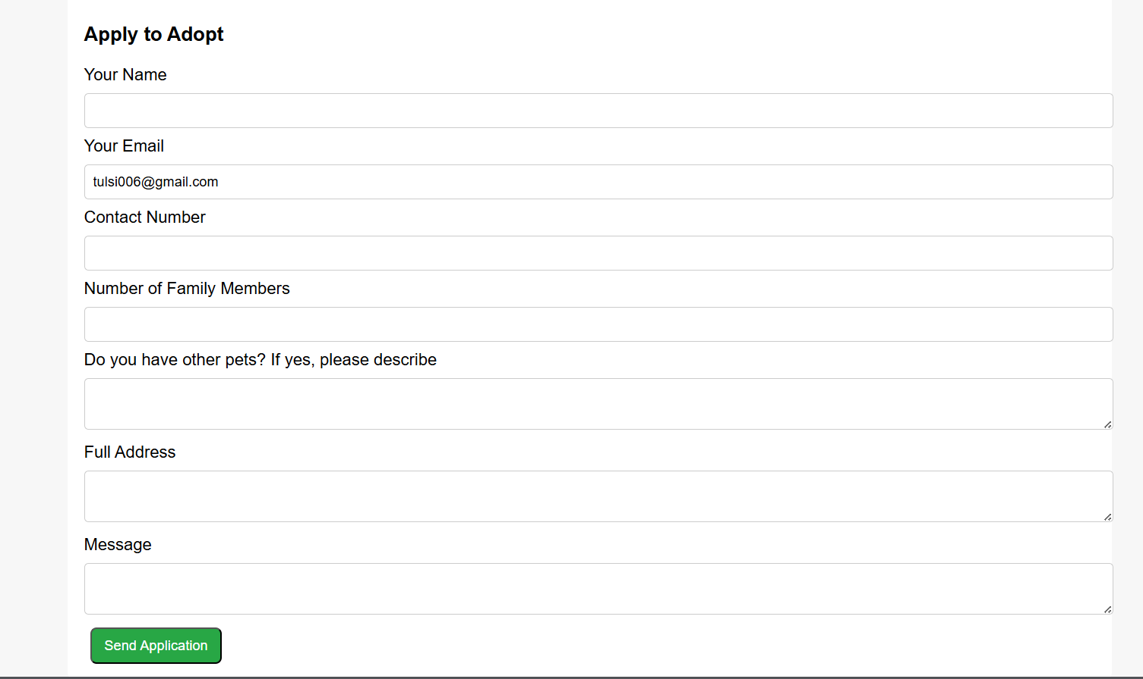

**Figure 5.5.2 Pet Page**

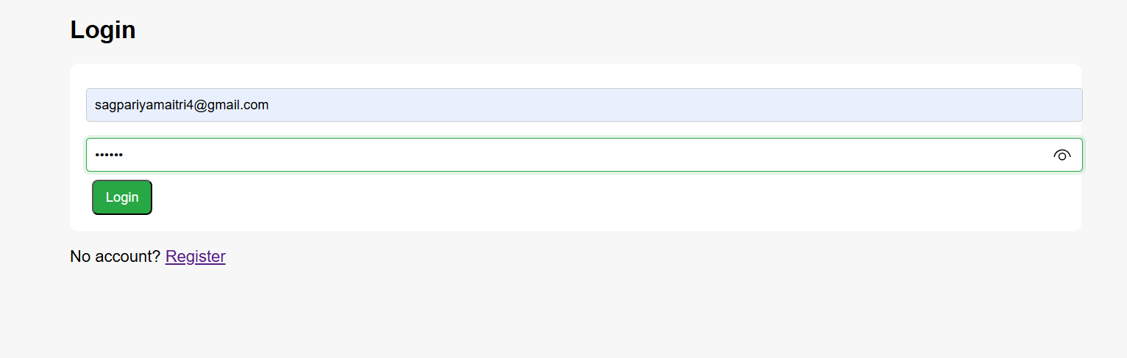

**Figure 5.5.3 Login Page**

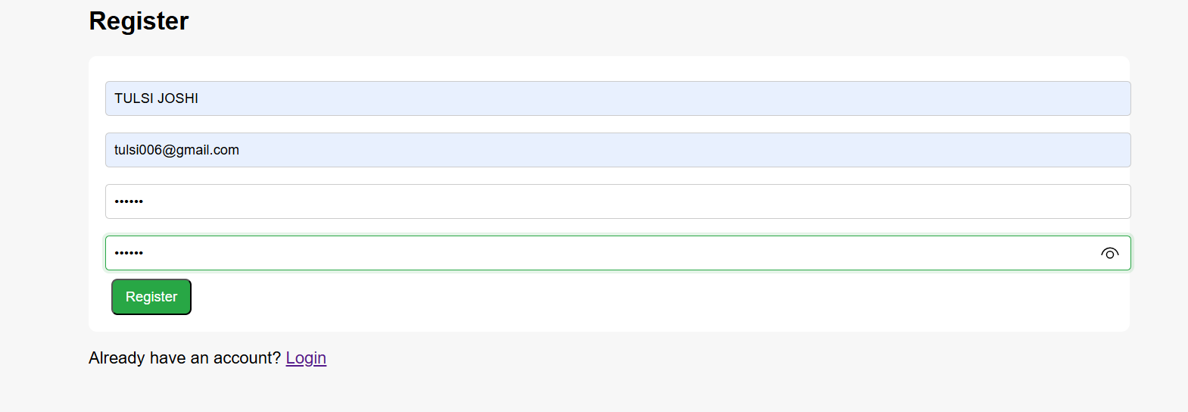

**Figure 5.5.4 Register Page**

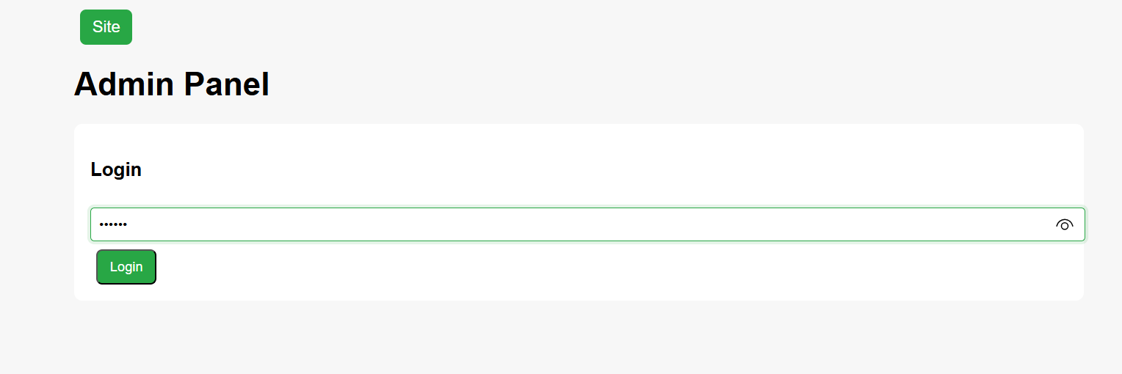

**Figure 5.5.5 Admin Page**

# ****6.Conclusion****

The Pet Adoption System is a simple and useful online platform that makes the process of adopting pets easier and faster. It connects adopters wit

h pet owners and shelters in one place, so there is no need for traditional time-consuming methods. The system includes important parts like user management, pet listing, adoption requests, and administration. Adopters can easily search for pets, send adoption requests, and check their status from anywhere. Administrators can manage pet details, user accounts, and applications in a convenient way. This project removes the problems of offline adoption by giving online access, clear information, and easy use for everyone. It is built using PHP and MySQL, which makes it lightweight, reliable, and easy to improve in the future. Working on this project also gives good learning experience in web development and shows how technology can solve real problems in daily life. The system is designed to be flexible and can grow with new features like mobile apps, notifications, or smart pet recommendations. Overall, it makes adoption simple, saves time, and builds trust between adopters and shelters. It not only benefits the adopters by helping them find pets quickly but also helps administrators handle everything more effectively. The system shows how digital platforms can make a big difference in social causes. It is practical, user-friendly, and meaningful.

# ****7.Learning During Project Work****

During the development of the **Pet Adoption System**, several important skills and concepts were learned and applied. The key areas of learning can be summarized as follows:

### Technical Learning

1. **Web Development Basics**

* Learned how to build web applications using PHP, HTML, CSS, and JavaScript.
* Practiced creating simple, responsive, and user-friendly designs.

1. **Database Management**

* Understood how relational databases work and used MySQL for practice.
* Created ER diagrams and wrote queries for adding, updating, and deleting data.
* Learned to connect PHP with MySQL safely using db.php.

1. **Authentication and Security**

* Made login and logout systems for users and admins.
* Learned session handling and form validation to keep data safe.

1. **Software Engineering Concepts**

* Practiced use case diagrams, activity diagrams, and sequence diagrams.
* Learned to divide the project into small, manageable parts (modular design).

1. **Project Deployment**

* Learned to use XAMPP/WAMP as a local server.
* Practiced testing and fixing errors in the web application.

### Non-Technical Learning

1. **Problem-Solving Skills**

* Understood real problems in pet adoption and thought of digital solutions.

1. **Teamwork and Collaboration** (if group project)

* Improved communication and shared work with team members.

1. **Time Management**

* Learned to plan tasks, set goals, and finish work on time.

1. **Documentation Skills**

* Gained experience in writing project reports with diagrams, requirements, and details.

# ****8.Refference****

### 8.1 Online References:

* MySQL Documentation
* W3Schools (for PHP, HTML, CSS tutorials)
* AI Tools (for coding help and explanations)

### 8.2 Offline References:

* Prof. Jignesh Hirpara (guidance and lecture notes)